We have been notified of this application and would like to submit comments.

As the Governments forestry experts, we endeavour to provide as much relevant information to enable the project to reduce any impact on irreplaceable habitat such as Ancient semi natural Woodland as well as other woodland. We are particularly concerned about any impact on Ancient Semi natural Woodland and will expect to see careful consideration of any impact when assessing the site.

The site is directly adjacent to Dell Wood and Long Newland’s Spring Ancient Semi Natural Woodlands, with Green Lane Ancient Semi Natural Woodland within the site.

Ancient Woodland:

Ancient woodlands are an irreplaceable habitat. They have great value because they have a long history of woodland cover, being continuously wooded since at least 1600AD with many features remaining undisturbed.
Decisions should be made in line with paragraph 193 (c) of the National Planning Policy Framework (Dec 2024), which states:
“Development resulting in the loss or deterioration of irreplaceable habitats (such as ancient woodland and ancient or veteran trees) should be refused, unless there are wholly exceptional reasons and a suitable compensation strategy exists”
As Ancient woodland, ancient trees and veteran trees are irreplaceable, you should not consider proposed compensation measures as part of your assessment of the merits of the development proposal.
We particularly refer you to further technical information set out in Natural England and Forestry Commission’s Standing Advice on Ancient Woodland – plus supporting Assessment Guide and “Keepers of Time” – Ancient and Native Woodland and Trees Policy in England.
The Joint NE/FC Standing Advice states that both the direct and indirect effects of development should be considered for both the construction and operational phases of the proposed development.

Not just including the potential for actual construction to impact on soils, trees and tree roots. But also the potential for effects when the residential development is in use.

Other impacts to the ancient woodland, for example reducing the resilience of the woodland and making it more vulnerable to change. Increasing the amount of dust, light, air and soil pollution and increasing disturbance to wildlife, also trampling of plants, erosion of soil and noise from additional people, traffic and domestic pets.
Ancient Woodland Buffer:
The Standing Advice also states that proposals should have a buffer zone of at least 15m from the boundary of ancient woodlands to avoid root damage which can result in loss or deterioration of the woodland. Where assessment shows impacts are likely to extend beyond this distance, you’re likely to need a larger buffer zone. For example, the effect of air pollution from development that can result from a significant increase in traffic.
Whilst we note plans for a 30m buffer for the ancient woodlands, and plans for thorny shrub planting in the buffer zone, the application may still have the potential to cause deterioration to the ancient woodland. Although the buffer may be sufficient to avoid direct soil compaction during construction, indirect soil damage and disturbance would still be expected due to the extent of the proposed development. Impacts from machinery, movement of the workforce and from new residents would be expected to cause a deterioration.
We would encourage considering a mix of habitat types to create a graded edge from the existing woodland including new woodland, scrub and species rich grassland with effective management that maximises biodiversity value. We also note the inclusion of amenity public open space and footpaths within the Ancient woodland buffer, these may be better located outside of the buffer, with the buffer itself managed as a semi natural habitat less attractive to be used as public open space.
Priority Habitat:
Both Dell Wood and Green Lane Wood are also listed as mixed deciduous woodlands on the National Forest Inventory and the Priority Habitat Inventory (England).
They were recognized under the UK Biodiversity Action Plan as being the most threatened, requiring conservation action. The UK Biodiversity Action Plan has now been superseded but this priority status remains under the Natural Environment & Rural Communities Act 2006. (NERC) Sect 40 “Duty to conserve and enhance biodiversity” and Sect 41 – “List of habitats and species of principle importance in England”.
Paragraph 187b of the NPPF states:
“Planning policies and decisions should contribute to and enhance the natural environment recognising the intrinsic character and beauty of the countryside, and the wider benefits from natural capital and ecosystem services – including the economic and other benefits of the best and most versatile agricultural land, and of trees and woodland.”
Habitat Fragmentation and Connectivity:
Fragmentation is one of the greatest threats to mixed deciduous woodland and especially ancient woodland. Woodlands can suffer loss or deterioration from nearby development through damage to soils, roots and vegetation and changes to drainage and air pollution from an increase in traffic and dust, particularly during the construction phase of a development.
The proposed development will not improve habitat connectivity between Dell Wood, Long Newland’s Spring and Green Lane Wood. In fact, it could sever it completely. With Green Lane Wood becoming completely isolated in its landscape. While managed grassland and play areas are to be provided, there is a greater opportunity to provide habitat connectivity between Green Lane Wood and Dell Wood in particular.
With current plans, there would be very limited movement of species (flora and fauna) between habitat areas and therefore the species quality and diversity in the smaller, isolated woodland would likely decline and would be unlikely to improve (especially without appropriate management) and would further impact the woodland’s resilience to future threats including climate change. The measures taken by the application to offset the proposal do not appear to take account for habitat connectivity or continuity.

Whilst we understand that all trees and woodlands on site will be retained, there is an opportunity for increased woodland planting between the two woodlands to improve connectivity across the whole landscape.

Hedgerows, individual trees and woodlands within a development site should be considered in terms of their overall connectivity between woodlands affected by the development. Perhaps with the creation of some larger woodland blocks and hedgerow/hedgerow trees between the existing woodland blocks on site, to link them and ensure maximum gains to increase habitat connectivity, to make woodlands more resilient and to benefit biodiversity across the whole site

Canopy Cover and Woodland Management:
With the Government aspiration to increase tree and canopy cover to 16.5% of land area in England by 2050, The Forestry Commission is seeking to ensure that tree planting is a consideration in every development not just as compensation for loss.
The species and provenance of new trees and woodland needs to be considered to ensure a resilient treescape which can cope with the full implications of a changing climate. The biosecurity of all planting stock also needs to be considered to avoid the introduction of pests and diseases, particularly in areas near ancient woodlands.

Plans should also be in place to ensure the long term management and maintenance of new and existing woodland, including deer management and would recommend the creation of a UK Forestry Standard compliant management plan, access also needs to be considered for future management.
Active management of woodlands, especially ancient woodlands, is essential for a host of reasons but crucially to create and maintain the valuable biodiversity element of these habitats. This diversity leads to greater resilience and productivity along with environmental benefits. The diversity and benefit of woodlands will be lost over time if they are neglected. These interventions are also crucial in the face of climate change where active management is needed to help woodlands adapt.
If the Local Authority is minded to approve this application, we would recommend that full details of any woodland protection measures, a woodland management plan, a planting plan including species selection and lighting strategy to avoid illuminating all woodlands on site and adjacent to it, be provided at the reserved matters stage.
We hope these comments have been useful to you. If you require any further information, please do not hesitate to contact me.
Best wishes
Sandra

Sandra Squire

Local Partnership Advisor
East & East Midlands

Tel: 07900 227123
Sandra.Squire@forestrycommission.gov.uk

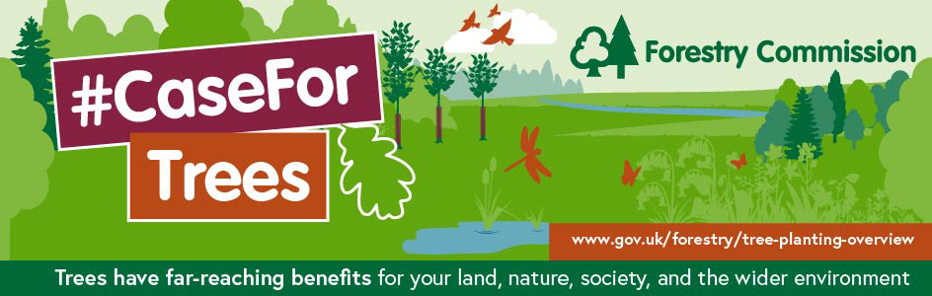
Subscribe to our newsletter to be the first to hear about the latest information, advice, and news from the Forestry Commission

